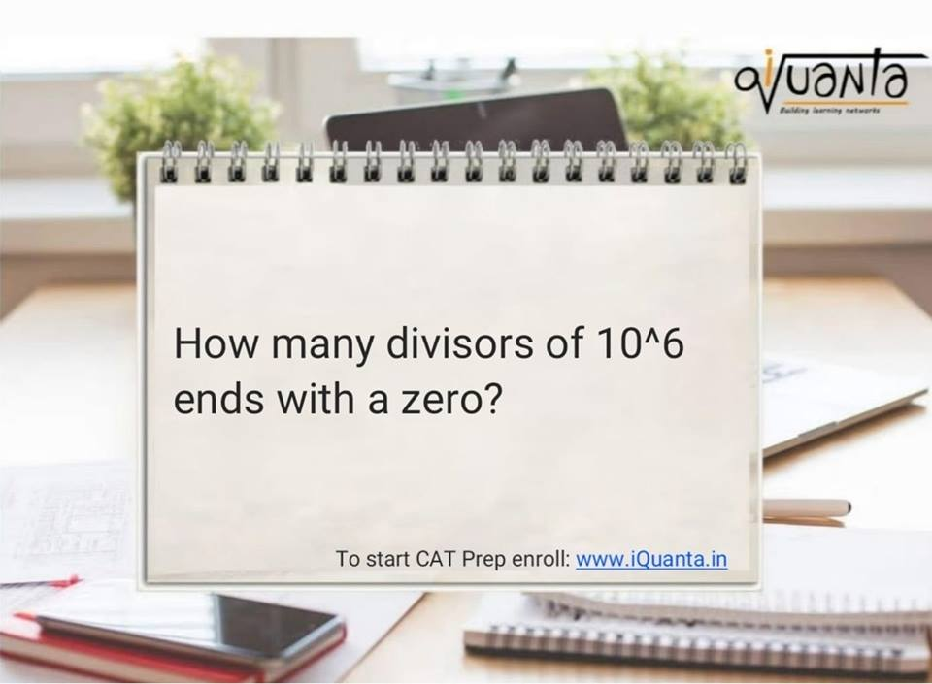

"a zero" https://static.xx.fbcdn.net/images/emoji.php/v9/f51/1/16/1f603.png:D   
  
Atleast one zero - Atleast 2 zeroes = One zero   
  
So 10(2^5*5^5) - 100(2^4*5^4)   
  
=> (6 x 6 ) - (5 x 5 )   
  
=> 11   
  
[#iQuanta](https://www.facebook.com/hashtag/iquanta?hc_location=ufi)   
  
It was a trick question Mitron!!

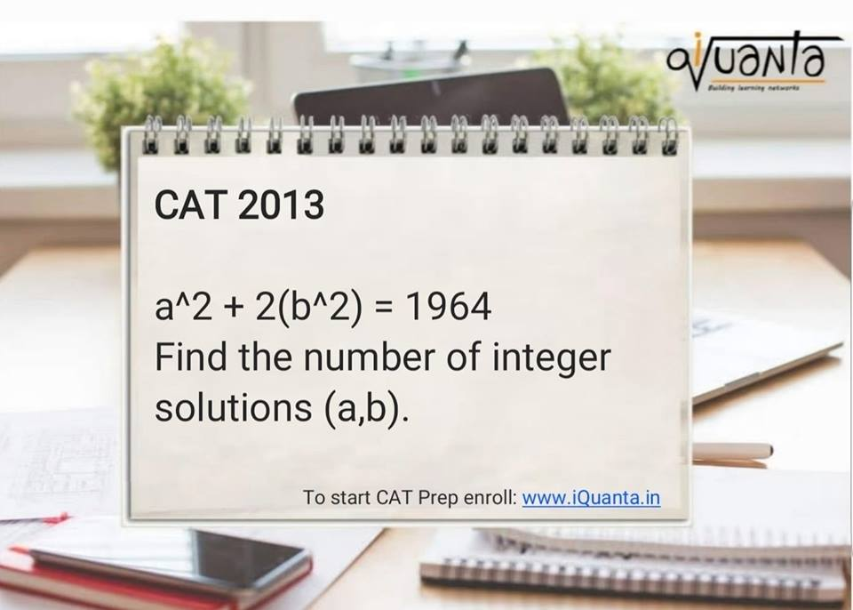

[***Group admin***](https://www.facebook.com/indrajeetsinghrock?fref=gs&dti=370097693157939) a^2 + 2b^2 = 1964  
a^2 ends with 1,4,9,6,5  
2b^2 ends with 2,8,0  
possible combinations : 4+0 or 6+8  
  
case 1 : (4+0)  
a can be : 2,12,22,32,42,8,18,28,38  
b can be : 10,20,5,15,25  
now checking :  
42^2 +2* 10^2 = 1964  
  
case 2 : (6+8)  
a=6,16,26,36,4,14,24,34,44  
b=2,3,12,13,22,23  
no value  
  
So a=42,b=10  
a=-42,b=10  
a=42,b=-10  
a=-42,b=-10  
  
Total 4

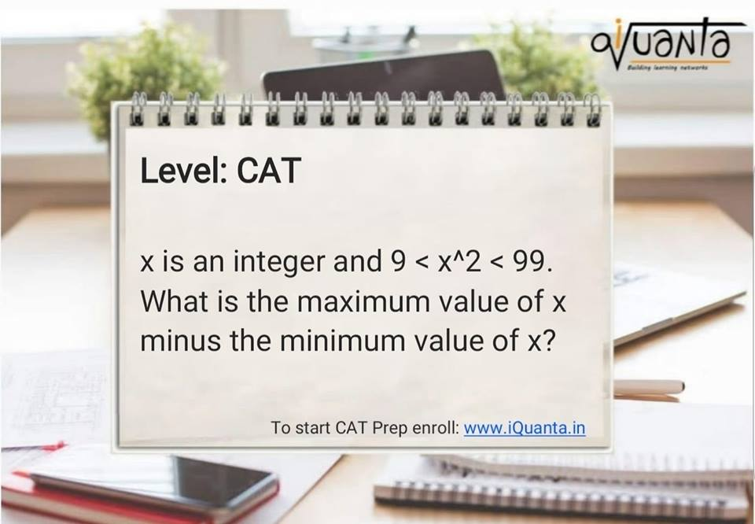

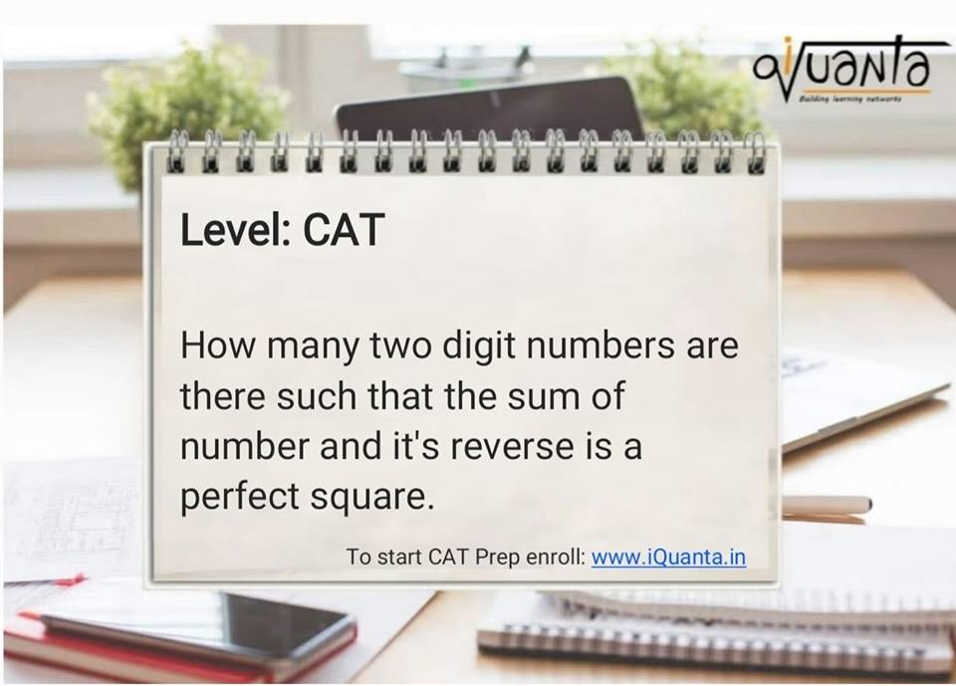

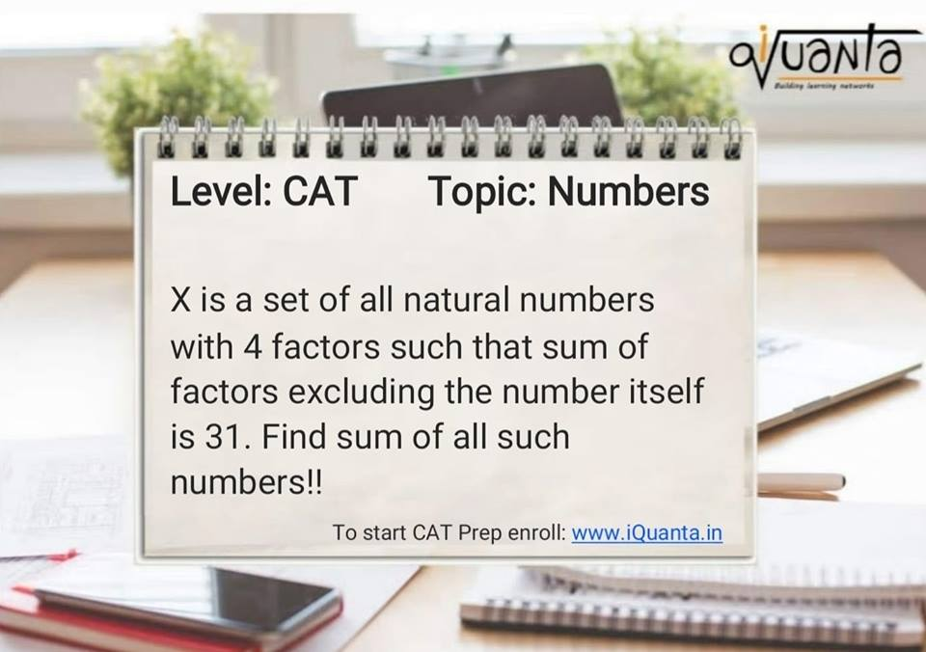

[**Indrajeet Singh*Group admin***](https://www.facebook.com/indrajeetsinghrock?fref=gs&dti=370097693157939) For 4 factors N must be either a*b or a^3  
  
case 1 : a*b  
factors : 1,a,b,ab  
1+a+b =31  
a+b=30  
coprime -> (7,23) (11,19) (13,17)  
  
p=a^3  
factors = 1,a,a^2, a^3  
1+a+a^2 = 31  
a+a^2 = 30  
a=5  
one solution  
  
sum = 161 +209 + 221 + 125 =716

